# CS 255 System Design Document Template

## UML Diagrams

### UML Use Case Diagram

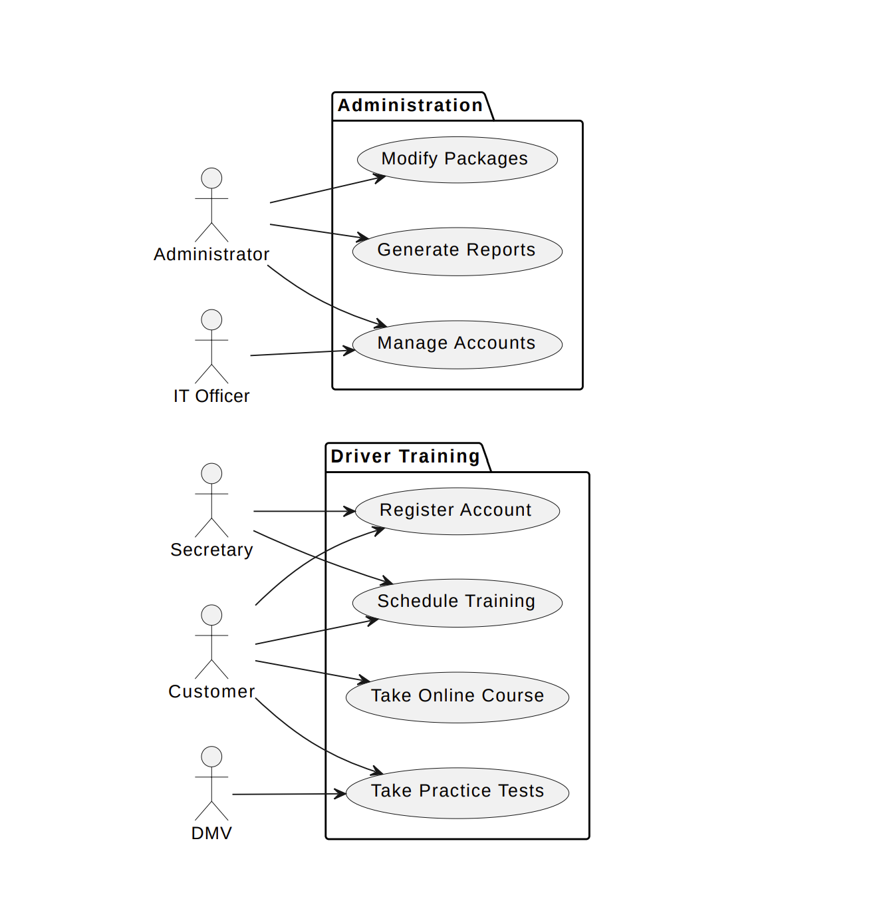

### UML Activity Diagrams

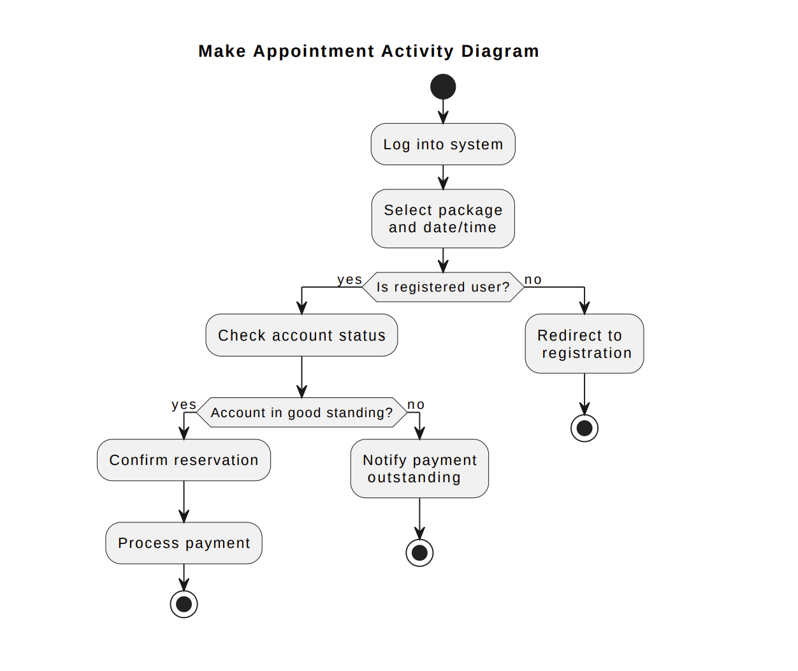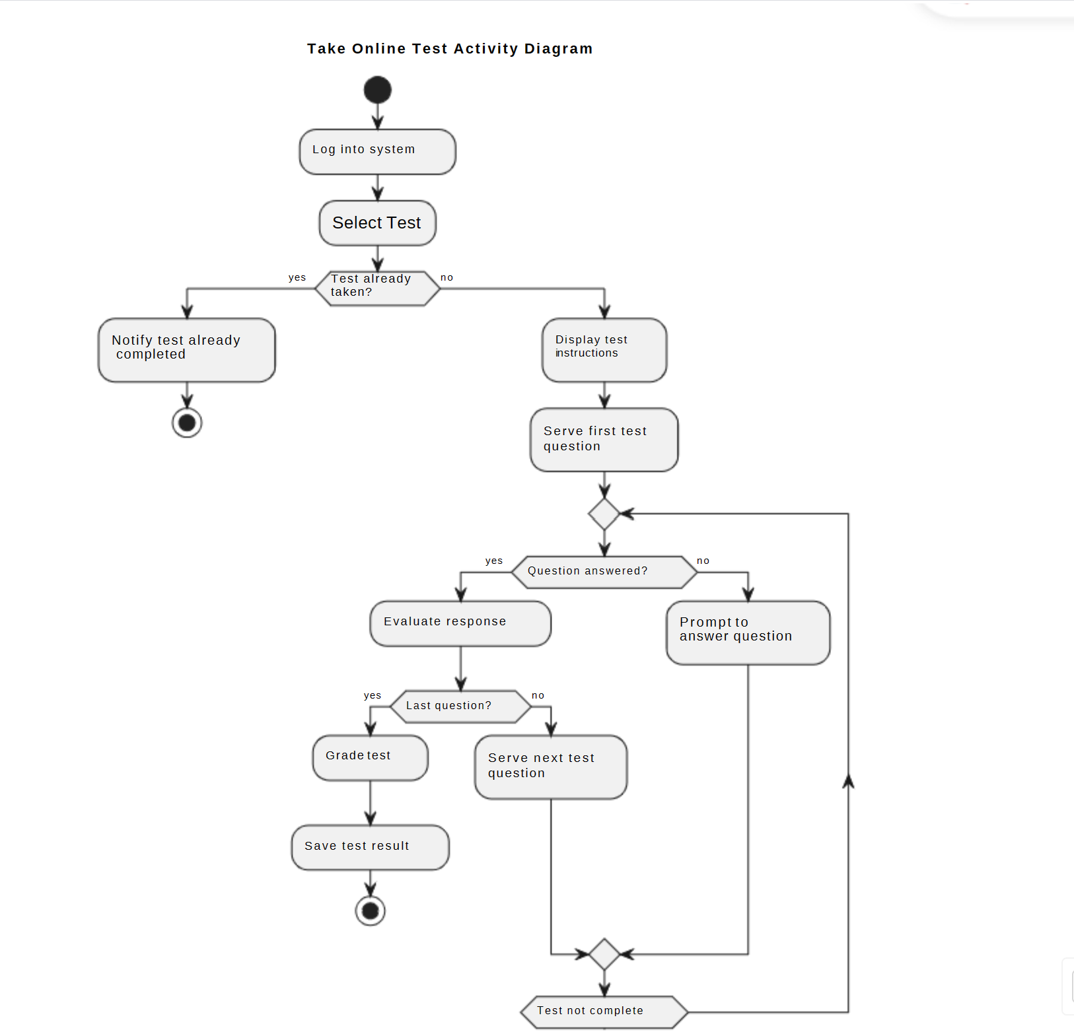

### UML Sequence Diagram

### 

### UML Class Diagram

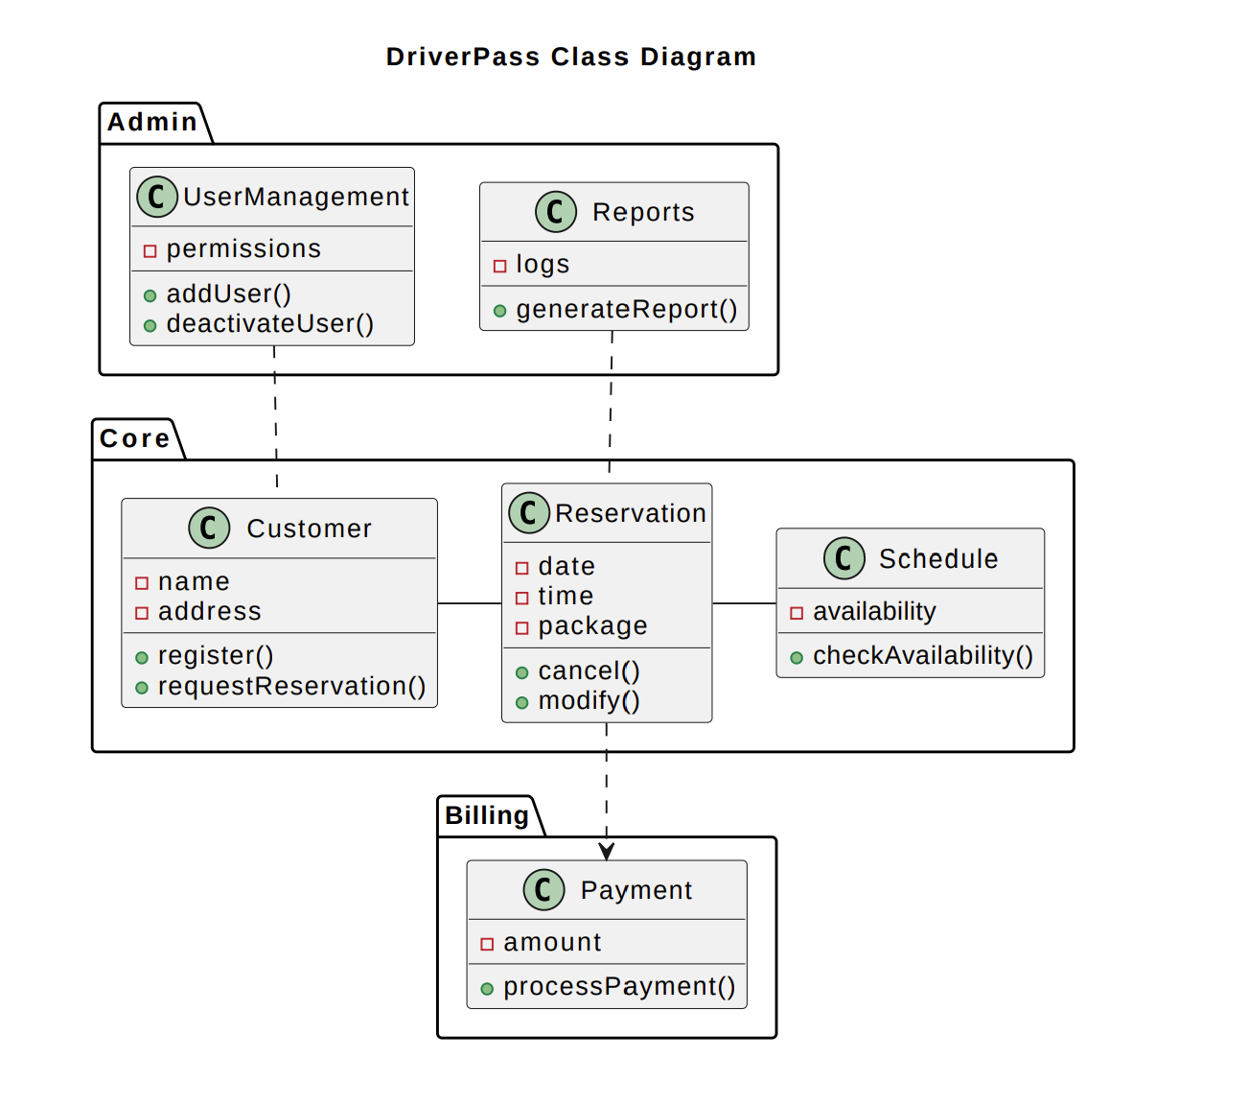

## Technical Requirements

**Cloud Infrastructure (AWS/Azure):**

Leveraging hyperscale cloud platforms as the hosting foundation centralizes control over availability, security, scalability, recoverability, efficiency, and maintainability benefits (Iorio & Snowdon, 2011). Cloud’s advanced capabilities for availability, security, scalability, disaster recovery, efficiency through automation, and maintainability through infrastructure-as-code surpass on-premise solutions for delivering a resilient, performant learning platform serving constituencies across several states.

**Linux Servers:**

Mainstream Linux distributions provide a proven secure and open-source hosting environment for the learning portal stack. Longstanding stability fixes mitigate disruption risks from underlying OS instability or excess technical debt accrued over software lifecycles.

Integrated Linux security modules assist in threat prevention via mechanisms for credentials isolation, system calls constraint, filesystem access whitelists, and process invocation rules. This hardens cloud-hosted Linux VMs beyond threats like code injections, malware execution, or API abuse. Upstream community security patching ensures alignment with the latest CIS benchmark recommendations for over 140 safe configuration controls.

The proliferation of Linux competence drives easier diagnostics and modernization. Configuration management prevents drift and scales secure ARM templates (Santyadiputra et al, 2021). The availability of community packages eases building out NodeJS, Angular, React, and Flask capacity. As an open platform, ongoing vendor independence saves licensing fees required by commercial solutions.

**MySQL Database:**

MySQL’s high-performance storage engine facilitates integral system functions from registering application details to emission documents while guaranteeing the transactional needed for payment and progress accuracy as pupils frequently engage new study units concurrently.

Line-level locking reduces collision which prevents intermediate data corruption that would have cascading impacts. SQL-based standard and custom reporting provide historical and granular business intelligence around completion rates or knowledge gaps that guide virtual classroom priorities per location.

Easy integration with prevalent development languages like JavaScript and Python accelerates queries, procedures, and application optimization without the learning curve lags of proprietary SQL variants. The relational organization integrates easily with supplemental analytical warehouses to prevent aggregation latency downsides. As growth continues over future quarters through state-level registrations, MySQL offers native sharding mechanisms to scale responsively across low-cost commodity clusters.

**JavaScript/Python Platform:**

Choosing JavaScript and Python empowers more rapid capability enhancements responding to evolving market feedback, student preferences, and best practices by balancing back-end efficiency with front-end interactivity.

Python accelerates the creation of supporting services like personalized study recommendations through its extensive libraries optimized for machine learning tasks. JavaScript enables progressively enhanced interfaces capturing real-time engagement telemetry via modern frameworks catering to complex components.

The abundance and proven scalability of talent in both languages minimize recruiting burdens as candidate expectations evolve regarding desired technology exposure. Community stewardship that maintains forward compatibility reduces the risk of major rewrite efforts over time.

**Payment Gateway Integration:**

Embedding PCI-compliant payment processing via vendor partnerships focuses internal teams exclusively on core educational content differentiation while leveraging specialized vendors to shoulder heavy compliance, encryption, and certification burdens related to revenue collection and retention (Khonda et al., 2022).

Delegating infrastructure, policies, and procedures maintenance overhead to payment gateways reduces audit mandates and lowers risk from gaps in encryption, tokenization, or access governance controls. Leveraging vendor-hardened flows, fraud detection capabilities, and global scale containing exploitable attack surfaces protects both students and the business.

Abstracting via consistent SDKs, sandbox test beds and built-in monitoring instrumentation available from payment leader APIs accelerates adding capabilities like financing options, subscription packaging or installment flexibility to better adapt to evolving student expectations.

**Encryption Protocols:**

Commitment to encryption, hashing, and key management controls de-risk exposure of passwords, personally identifiable information, or usage telemetry across transmission protocols and storage repositories even when infrastructure itself is compromised.

Transport layer encryption prevents data intercept through man-in-the-middle attacks of sensitive attributes like progress scores course and license registration details. Hashing and salting drive resilient credential storage such that recovery remains implausible even from data leaks. Proper key generation coupled with short validity periods ensures minimal exposure from capture. Securing secrets hierarchy prevents lateral pivot escalation.

Ongoing third-party penetration testing exercises secure independent validation of prevention efficacy over time as the internal team’s scale. Detailed remediation roadmaps strengthen real-world implementation practices beyond baseline compliance checklists.

**Browser-Based Access:**

Enabling learning through modern browsers removes technology adoption friction that otherwise discourages enrollment from digitally-savvy student generations across various devices from phones to tablets to computers.

Eliminating install barriers through portable web access dramatically expands addressable market size to all connected citizens rather than just desktop users with admin permissions across corporate or private machines. Browser consistency also streamlines supportability for the coaching staff.

A device-agnostic approach future-proofs accessibility to the emerging interface paradigms students increasingly gravitate towards as input mechanisms evolve via voice, wearables, and IOT appliances. Constructing adaptive learning journeys atop mature web standards protects content longevity.

**Responsive Web Design:**

Responsive front-end patterns persist in usability and convenience during transitions across small touchscreens to expansive desktop displays without disorientation through page mutations or lost insights that fracture learning continuity.

Interface resilience regardless of form factor expands student self-service flexibility to consume materials at their preferred device already on hand without workflow disruption forcing hardware changes mid-session due to rendering loss. Dynamically adaptive designs thus foster student-centric learning venues.

Progressively enhanced components progressively add value across capability spectra without regression. Graceful degradation protects baseline content availability by correlating component complexity to network conditions and hardware limits. Validation ensures accessibility compliance amidst fluid layouts. Intuitive menus, badges, and site orientation safeguard context through transformations.

**Reference:**

Iorio, F., & Snowdon, J.L. (2011). Leveraging cloud computing and high performance computing advances for next-generation architecture, urban design and construction projects. *Spring Simulation Multiconference*. [Leveraging cloud computing and high performance computing advances for next-generation architecture, urban design and construction projects | Proceedings of the 2011 Symposium on Simulation for Architecture and Urban Design (acm.org)](https://dl.acm.org/doi/10.5555/2048536.2048551)

G S Santyadiputra et al (2021) The effectiveness of *Automatic Network Administration* (ANA) in network automation simulation at Universitas Pendidikan Ganesha J. Phys.: Conf. Ser. [The effectiveness of Automatic Network Administration (ANA) in network automation simulation at Universitas Pendidikan Ganesha - IOPscience](https://iopscience.iop.org/article/10.1088/1742-6596/1810/1/012028)

Khando, Khando & Islam, M Sirajul & Gao, Shang. (2022). The Emerging Technologies of Digital Payments and Associated Challenges: A Systematic Literature Review. Future Internet. [Download citation of The Emerging Technologies of Digital Payments and Associated Challenges: A Systematic Literature Review (researchgate.net)](https://www.researchgate.net/publication/366700399_The_Emerging_Technologies_of_Digital_Payments_and_Associated_Challenges_A_Systematic_Literature_Review/citation/download)